Ashvini Krishnan

Netid = akrshnn6

ASTR 414 HW 9

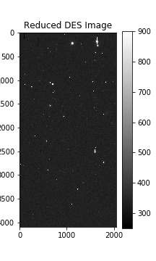**Reduced DES Image with a gray color map:**

**Figure 1:** Reduced DES image with a gray color map, with vmin = 250 and vmax = 900

The offset of the DES image from the 2Mass image is ___. To get the offset value, I used the DS9 program to view the new fits file of the reduced image and used the fk5 coordinates of α (right ascension) and δ(declination) to get the same area of stars from the 2Mass website. Once I got the 2Mass image, I uploaded that to DS9 as well. I then matched the two frames to WCS coordinates and selected a source from the reduced DES image and found its corresponding coordinates on the 2Mass image. The difference between those two numbers is the offset.